**Visvesvaraya Technological University**

# Belagavi, Karnataka, 590 018.

## **A Seminar Report on**

**“Android Vulnerabilities & Security”**

(15CSS86)

Submitted in partial fulfillment of the requirements for the award of

**Bachelor of Engineering**

**in**

**Computer Science and Engineering**

**Semester VIII**

**Academic Year 2019-2020**

Submitted By

**Mr. Sagar F.Honnabindagi**

**(USN: 2KE16CS040)**

Under the Guidance of

**Mr. Kiran B. Malagi**

**Assistant Professor, Dept of CSE, KLEIT, HUBLI**

***Department of Computer Science & Engineering***

|  |  |  |
| --- | --- | --- |
|  | K. L. E. SOCIETY’S**K. L. E. INSTITUTE OF TECHNOLOGY,**Opp. Airport, Gokul, Hubballi-580 030Phone: 0836-2232681 Website: www.kleit.ac.in |  |

|  |  |  |
| --- | --- | --- |
|  | K. L. E. SOCIETY’S**K. L. E. INSTITUTE OF TECHNOLOGY,**Opp. Airport, Gokul, Hubballi-580 030Phone: 0836-2232681 Website: www.kleit.ac.in |  |

**DEPARTMENT OF COMPUTER SCIENCE & ENGINEERING**

**CERTIFICATE**

Certified that the seminar work entitled **“Android Vulnerabilities & Security”** is a bonafide work carried out by **Mr. Sagar F.Honnabindagi,** bearing USN number **2KE16CS040**, in partial fulfillment for the award of degree of **Bachelor of Engineering** in **VIII Semester,** **Computer Science and Engineering** of **Visvesvaraya Technological University**, Belagavi, during the year **2019-2020**. It is certified that all corrections/suggestions indicated for internal assessment have been incorporated in the report deposited in the department library. The seminar report has been approved as it satisfies the academic requirements in respect of seminar work prescribed for the said degree.

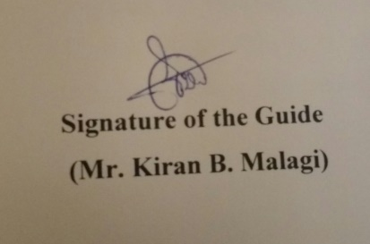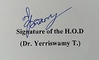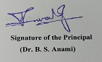

**Name of the Examiners Signature with Date**

**1.**

**2.**

**3.**

**ACKNOWLEDGEMENT**

The seminar report on **“Android Vulnerabilities & Security”** is the outcome of guidance, moral support and devotion bestowed on me throughout my work. For this I acknowledge and express my profound sense of gratitude and thanks to everybody who have been a source of inspiration during the project work.

First and foremost, I offer my sincere phrases of thanks with innate humility to our **Principal Dr. B. S. Anami** who has been a constant source of support and encouragement. I would like to thank our **Dean Academics Dr. Sharad Joshi** for his constant support and guidance. I feel deeply indebted to our **H.O.D. Dr. Yerriswamy T.** for the right help provided from the time of inception till date. I would take this opportunity to acknowledge our **Guide Mr. Kiran Malagi,** who not only stood by us as a source of inspiration, but also dedicated his/her time for me to enable me present the project on time. I would be failing in endeavor, if I do not thank our **Coordinator Dr. Geeta R. Bharamagoudar** who has helped me in every aspect of my seminar work.

Last but not the least, I would like to thank my parents, friends & well-wishers who have helped me in this work.

Sagar F.Honnabindagi

**ABSTRACT**

Market share of Android device is increasing and these devices are now important part of one’s daily routine. Most of our sensitive data is stored in these devices. This seminar focuses on various vulnerabilities which an Android user might be exposed to and ways protect themselves from these vulnerabilities. Third party apps are the major way to steal data from users, logging their private information and using it to carry out crime. Understanding what is the current condition of the Security for these devices and how we can prevent leakage of personal information.

Smartphone becomes the most typical and popular mobile device in recent years. It combines the functionality of mobile phone and PDA. Besides, it provides many computers’ functionality, such as processing, communication, data storage and etc. It also provides many computers’ service, such as web browser, portable media player, video call, GPS, Wi-Fi and etc. This seminar analyses and compares the feature and security issue among three popular brands of smartphones (Google Android, iPhone and BlackBerry) aiming to help customers choose suitable mobile device based on their specific needs.

Android is the most widely used mobile operating system today. As the world grows more data-driven, people are storing more and more sensitive information on their mobile devices; security is more important than ever. This paper details the possible security issues with Android devices, countermeasures, and real-world examples of past attacks in order to provide users and developers with a better understanding of the risks and limitations surrounding the platform.